**NestUp BD**

A Smart Relocation Support Platform

**Team Members**

* Ahnaf Shahriar Pias (220042146)
* Md. Sameur Rahman (220042144)
* Irfan Shafee (220042164)

**Supervisor**

Md. Tariquzzaman,

Junior Lecturer,

Department of Computer Science & Engineering,  
Islamic University of Technology, Gazipur

**Project Overview**

NestUp BD is a digital relocation support platform that helps students, job holders, and professionals to easily find verified housing solutions when moving to a new city in Bangladesh. Initially focused on the housing aspect, the platform also integrates basic food and water arrangements through verified hosts. The goal is to reduce the stress and uncertainty involved in relocating, especially during admission seasons or job transfers.

**Motivation Behind the Project**

Relocation—particularly among students and professionals—is very common in Bangladesh. Cities like Dhaka, Rajshahi, Khulna, and Sylhet see high inflow during university admissions, job changes, or internships. Current relocation practices are informal, unverified, and time-consuming. NestUp BD aims to solve these issues by providing a centralized, reliable platform.

**User Requirement Analysis**

1. **Student Relocator**: kefayat, an HSC graduate from Rangpur, goes to Khulna attend the admission test of KUET. He has no friends or family there. He needs a short-stay verified rental room, preferably with basic food/water.
2. **Homeowner in Khulna**: Mr. Robin has a flat with extra rooms and wants to rent out during the KUET admission season. He seeks an easy way to post and manage verified listings and receive rent from verified tenants.

User needs:

* Verified, gender-filtered housing listings
* Clear pricing, location filtering
* Temporary meal or water support
* Emergency contact or help

**Key Features of the Project**

1. **Housing**

* Short/Long Stay Housing Finder
* Room Sharing Options
* Gender Filter
* Verified Host Badge

1. **Transport**

* Local Ride Booking
* Vehicle Type Selection

1. **Food & Water**

* Meal Plans
* Water Delivery
* Hygiene Badge

1. **Stationery**

* Stationery Packs
* Urgent Delivery
* Fair Pricing

1. **Booking & Ratings**

* In-app booking
* Service rating and review

1. **Provider Dashboard**

* Post gig (room available)
* Monitor status and ratings

**Flow Chart**

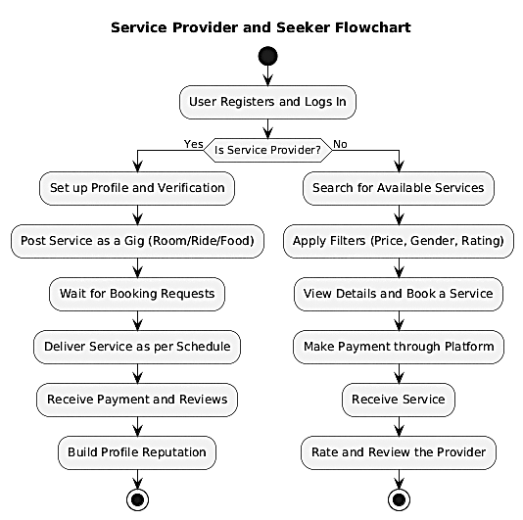

**Tools and Technologies**

* **Frontend**: React.js
* **Backend**: Node.js / Express.js
* **Database**: MongoDB / Firebase
* **Version Control**: Git (GitHub)

**Proposed Timeline**

**Week 1–2: Idea Selection & Requirements Gathering**

* + Brainstorming and concept finalization
  + Identifying core and secondary features based on real-life needs

**Week 3: Proposal Submission**

* + Preparing and submitting the written proposal

**Week 4–5: Initial System Design**

* + Planning overall system architecture and user flows

**Week 4–10: Core Feature Development**

* + Main features such as "House Finder" and "Transport" module development

**Week 9–12: Add-on Features Development**

* + Developing integrated "Food" and "Stationery" modules (limited scope as per suggestions)

**Week 6–14: Testing & Debugging**

* + Ongoing system testing, bug fixing, and feedback evaluation

**Week 11–13: System Optimization**

* + Performance tuning and UI/UX refinement

**Week 14: Deployment**

* + Final deployment and potential demo or submission
* ***As we were suggested to reduce and integrate some of the features, the timeline might need to be modified as we go on with the project.***

**Suggestions Received from Faculty During Proposal Presentation**

1. Scope of the project is too high—reduce it.
2. Keep "House Finder" as the **core/main feature**.
3. Integrate **Food** as an add-on inside housing listings.
4. **Stationery service is not that much necessary** and can be removed.